---------- # Activities # ----------

MainActivity - used for displaying a splash screen in which "Fitness App" text is displayed. We created a handler with a timeout of 3 secs. After 3 secs user will be directed to HomeActivity page.

HomeActivity – used to display buttons for goals which include weight reduction, get toned, build muscles. On clicking any button user will be directed to WorkoutHome page.

ReportActivity – used to display the details of exercises, workouts done by user

MeActivity – used to display button for my profile, remainder, set rest time, set countdown time, rate us, privacy policy etc

WorkoutHome – after selecting any goal user will be directed to WorkoutHome which displays workouts included in selected goal through cardview. After choosing any workout that user wishes to perform, user will be directed to ExerciseHome page. Has recycleview for workout cardviews inside scrollview.

ExerciseHome – after choosing workout which user wishes to do he/she will be directed to ExerciseHome which will display exercises included in selected workout. On this page exercises are displayed. If user clicks on any of them dialog box will appear showing how to do that exercise. To start workout user has to click on start button , through which user will be directed to RestActivity page. Has recycleview for exercise cardviews inside scrollview.

RestActivity – In this exercises will be taken from database and loop will be run on list of exercises.

ExecuteExercise – through RestActivity for each exercise user will be directed towards this activity which will display gif, name and countdown of exercise. It has pause button, next button, and back button.

ProfieActivity – used to display a user's health profile. Users can change the details, and can view them in either kg cm or lb ft.

RemainderPage – used to display reminders created by the user through cardview. Has recycleview for remainder cardviews inside scrollview.

Remainder – used to create a remainder and add it to the user's database.

RateUs – used to take rating from user

Feedback – used to take feedback from user

PrivacyPolicy – used to display privacy policy of our app

NotificationMessage – used when notification of remainder is displayed

----------- # Database # -----------

**Database Name** – FITNESS_DB

**Database tool used** – SQLite

Since our application required some tables to be created from our side and then uploaded to the user we did not create a database in the user's device rather used an already created database.

Tables and their details:

1. **Exercises**

Use – used to store details of each exercise

Columns :-

ID – primary key, auto incremented used for identifying exercise

Name - name of exercise

Time – amount of time for which exercise is to be executed

Calories – amount of calories burned after completing exercises

Info – how to do exercise

GIF – link of exercise gif

1. **Workouts**

Use – used to store name and details of each workout

Columns –

ID – primary key, auto incremented used for identifying workout

Name – name of workout

Info – information/slogan about workout

Image – image associated with workout which is to be displayed in cardview

1. **WorkoutExercises**

Use – used to store in each workout which exercises are included

Columns –

Workout_id – foreign key, used for workout id which references ID from workouts table

Exercise_id – foreign key, used for exercise id which references ID from exercise table

1. **Goals**

Used to store goals in our application

Columns –

ID – primary key, auto incremented used for identifying goal

Name – name of goal

Image – image associated with goal which is to be displayed in cardview

1. **GoalsWorkouts**

Use - used to store in each goal which workouts are included

Columns –

Goal_id – foreign key, used for goal id which references ID from Goals table

Workout_id - foreign key, used for workout id which references ID from workouts table

1. **HealthDetails**

Use – used to store health details of user

Columns –

Date_of_recording – used to store date of recording of health data

Height – used to store height of user

Weight – used to store weight of user

1. **DailyWorkoutDetails**

Use – used store details of each exercise performed by user

Columns –

Workout_id – foreign key, used for workout id which references ID from workouts table

Exercise_id – foreign key, used for exercise id which references ID from exercise table

Date – date on which exercise was performed

Time – time for which exercise was performed

Calories – calories burned after performing exercise

1. **Remainder**

Use – used to store remainders created by user

Columns –

ID - primary key, auto incremented used for identifying remainder

Name – name of remainder

Date – date of remainder

Time – time of remainder

1. **CountdownRestTime**

Use – used to store rest time and countdown time as per requirement of user

Columns –

ID - primary key, auto incremented used for identifying user

CountdownTime – used to store countdown time user wants

RestTime – used to store rest time user wants

----------- # Java Classes Used for Database # -----------

These classes are used to store table names, column names of database. These classes are created with the purpose of loose coupling. If any column name or table name is changed then only changing attributes of these classes will be enough.

DatabaseDetails.java – Used to store details of database such as name of database, name of it’s tables, version number

Exercises.java – Used to store name of columns

Workouts.java - Used to store name of columns

WorkoutsExercises.java - Used to store name of columns

Goals.java - Used to store name of columns

GoalsWorkouts.java - Used to store name of columns

HealthDetails.java - Used to store name of columns

DailyWorkoutDetails.java - Used to store name of columns

Remainder.java - Used to store name of columns

CountdownRestTime.java - Used to store name of columns

DbHelper.java – Used to store functions which connect to database and get data

------------ # Model Classes # ------------

Model classes are used to represent data for example in case of exercise data ModelExercise is created which has attributes of exercise.

ModelExercise.java – used for exercise

ModelWorkout.java – used for workout

ModelGoal.java – used for goal

ModelWorkoutExercise.java – used to store data of WorkoutExercise table

ModelGoalWorkout.java – used to store data of GoalsWorkouts table

ModelRemainder.java – used for remainder

ModelHealthDetails.java – used for health details

ModelDailyWorkoutDetails.java – used for storing daily workout details

ModelCountdownRestTime.java – used for storing countdown and rest time details

-------------- # Adapter Classes # ----------------

Adapter classes are used to add dynamic data which is taken from database to recycleview in form of cardview. We have used a lot of recycleviews in our application so creating different adapters was necessary.

AdapterExercises.java – used for exercises

AdapterWorkouts.java – used for workouts

AdapterReport.java – used for history of workouts

AdapterRemainder.java – used for remainders

------------- # Misc. Classes # -------------

AlarmBroadcast.java – used to broadcast alr

------------- # CardViews # ---------------

CardView for Workout



CardView for Exercise

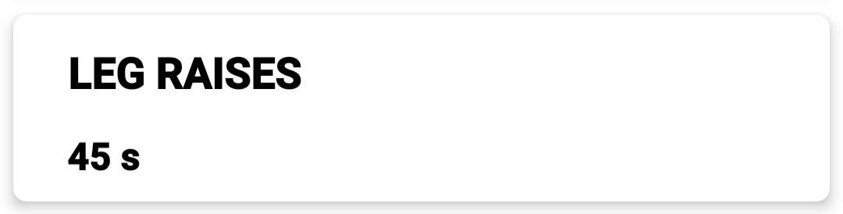

CardView for History of Exercise

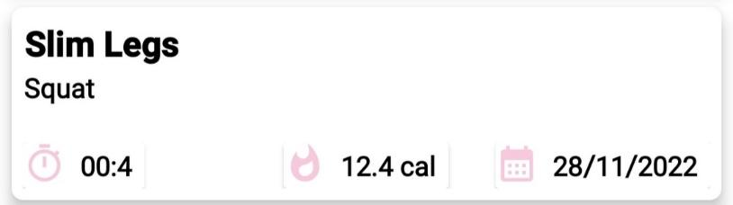

CardView for Remainder

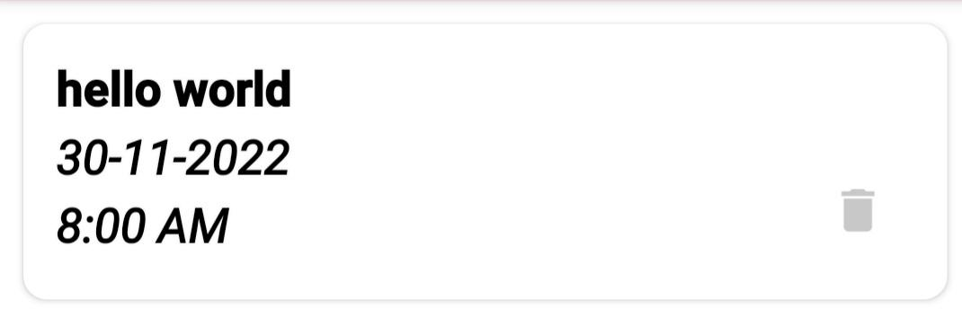

—----------- # UI components used # —--------------

* CardView
* RecycleView
* ScrollView
* RatingStar